IP3 2020 FOCUSED TECHNOLOGY CATEGORIES AND BRIEF DESCRIPTIONS
Advertising & Content Distribution | Online advertising through Blogs, Emails, Newsletters, Social Media, Shares, Product reviews, Mobile Advertising, etc., and content distribution via various media channels including Internet TV, CATV, VoD, Streaming Media, P2P, Broadband, etc.
Artificial Intelligence (AI) & Machine Learning (ML)  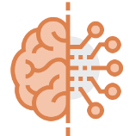 | AI creates intelligent machines that work like human brains. ML studies algorithms and statistical models to perform tasks with no external inputs. AI & ML are applied in fields such as Gaming, Natural Language Processing, Vision Systems, Speech Recognition, Intelligent Robots, and Handwriting Recognition. AI & ML are included in products such as Virtual Assistant, Voice Recognition, Flying Drones, Media Streaming Services, Smart Home and Content Personalization.
Augmented (AR) & Virtual Reality (VR) | Augmented reality (AR) is a type of interactive, reality-based display environment, which has capabilities of producing computer-generated display, sound, text and effects to enhance the user's real-world experience. Examples of AR devices include, Head mounted Displays, Smart Glasses, Smart Helmet, and APPs. VR technology most commonly uses VR headsets or multi-projected environments, sometimes combined with physical environments or props, to generate realistic images, sounds and other sensations.
Automotive & Mobility | Automotive deals with design, development, manufacturing, marketing, and selling of motor vehicles and its parts. Mobility covers multi-modal transport systems, VANETs (Platooning), Autonomous Fleets, Vehicle Electrification, Ride Sharing or Carpooling Services, Vehicle Software, Vehicle Control and Diagnostics, Electrical and Hybrid Vehicles, Vehicle Electronics, etc.
Blockchain & Financial Services | Blockchain is a growing list of records linked using cryptography with each record having a cryptographic hash of previous record, a timestamp, and transaction data. Blockchain is managed by a peer-to-peer network and provides secure and permanent ledger type of transaction. It is used in many industries for safe and simple data processing. Financial Services cover transactions related to Distributed Ledger, Digital ID, Data Sharing, Inventory Record Keeping, IOT, Banking, Transaction Security, Insurance, etc.
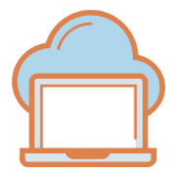  Cloud Computing & Web Service | Cloud computing covers on-demand availability of remote data storage, computing power and software. Web services cover the tasks performed through the Internet. Examples of cloud computing include SaaS, IaaS (infrastructure as a service), Virtualization, Distributed systems, web services, PaaS (platform as a service), RaaS (recovery as a service), DaaS (device as a service), Social Networking, Online Storage, Email, E-commerce, Searching, etc.
Computer Software & Hardware | Computer software relates to a set of instructions such as applications and the operating system. Computer hardware includes physical, tangible parts of a Computer, Server, Data Center, such as the Cabinet, Central Processing Unit, Monitor, Keyboard, Storage, Graphics Card, Sound Card,  Speakers, Motherboard, etc.
Health Tech & Healthcare IT  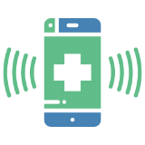 | Digital health solutions and devices that may use databases, applications, mobiles, wearables, image processing, web services to facilitate connected diagnosis, treatment and monitoring of health. Example devices include personal EKG, fitness bands, wearable smart devices, portable monitoring and diagnostic devices, electronic medical record, healthcare software, hospital management, telemedicine, robotic surgery, personal health monitoring APPs and software, etc.
Industrial & Manufacturing  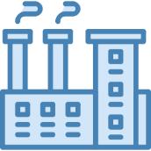 | Industrial covers various technologies related to industrial manufacturing such as automation, robotics, equipment, assembly, control systems, applications and software solutions for management of industrial processes, electrical and mechanical processes and procedures, etc.
Internet of Things (IoT) &  Smart Home  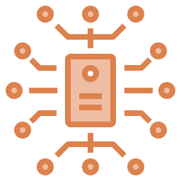 | IoT and smart home technology controls hardware devices and home appliances through the Internet. This technology includes Smart Appliances, Smart Lighting System, HVAC Systems, Smart Security Systems, Environmental and Industrial Monitoring Systems, Wearable Devices, Logistics Management, Retails Industry, etc.
LED Lighting & Optoelectronics | Optoelectronics cover electronic devices that source, detect and control light using components such as Photodiode, Solar Cells, LEDs and Laser Diodes. These devices can be found in many applications such as military services, telecommunications, automatic access control systems and medical equipment. LED lighting covers lights, luminaires, lighting devices, etc. that use LED as main source of light. It finds application in night lighting, art lighting, outdoor lighting, signage, lighting in electronics and automotive industries, etc.
Location-Based Services (LBS) / Navigation | LBS use real time geo data to provide information, entertainment or security. Several applications include proximity-based marketing, travel information, roadside assistance, mobile workforce management, mobile apps, advertisements, geo-fencing, media streamlining, monitoring real time location, etc.
Medical Devices & Imaging | Technology for clinical analysis and medical intervention. Example technology includes monitoring and diagnostic devices, sleep apnea and sleep therapy, diabetes monitoring and management, implants and prosthesis, spinal and orthopedics, magnetic particle imaging, photo acoustic imaging, endoscopic devices, tomography, echocardiography, surgical devices, radiography, MRI, nuclear medicine, ultrasound, cardiovascular, pulmonary and general surgery devices, etc.
Retail & E-commerce  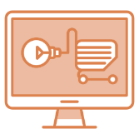 | Retail technology covers all aspects of the shopping experience through online and offline channels. E-commerce websites, store management solutions, customer experience and tracking, payment solutions, point of sale equipment, etc. are examples of the technologies included. It also includes order management and fulfillment, inventory tracking and management, warehouse management and automation, and retail hardware (displays, signage, etc.).
Semiconductor Manufacturing & Equipment  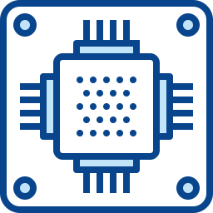 | Semiconductor technology covers components, devices and processes used for fabricating components and ICs. Exemplary products include dicing machine, probing machines, sliced wafer demounting, cleaning machine, wafer edge grinding machine, polish grinders, transistors, chips, FPGAs, ICs, etc.
Wireless & Telecommunication  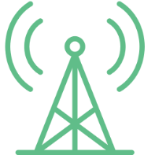 | This technology relates to exchange of information over significant distances and refers to all types of voice, data and video transmission, Mobile Phones and Devices, Network technologies such as M2M communications, vehicle-to-vehicle communication, Adhoc-networks, LTE, LTE-Advanced, 3G, Wi-Fi, routers, base stations, protocols, conferencing, satellites, antennas, wireless ICs, broadband, telephones (wired and wireless), microwave communications, fiber optics, satellites, television broadcasting and telegraphs, communication software, billing and service plans, call centers, PBX systems, telecom monitoring, Bluetooth, NFC, RFID, etc.

